1. 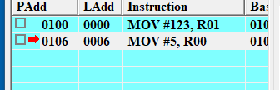

2. 

3. 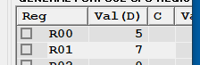

4. 

5. 

6. ✅

7. 

8. The Z box is checked

9. None of them is checked

10. ✅